准备工具：EP7 PRO*1 标配USB线*1

文件包：Icatch V30驱动包*1、EP7L固件刷机包*1

Tools required: EP7 PRO*1, Standard USB cable*1  
File package: Icatch V30 driver package*1, EP7L firmware flashing package*1

1.双击Icatch V30驱动包以默认路径安装。

Double-click the Icatch V30 driver package to install it to the default path.

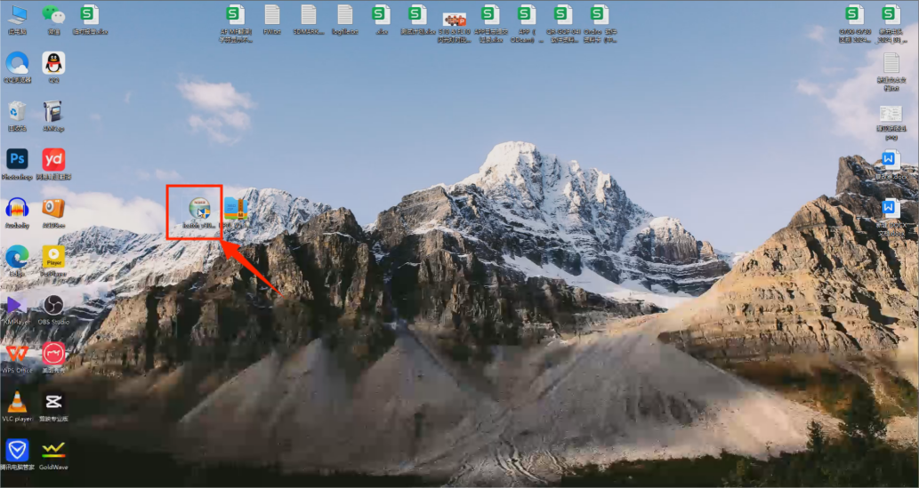

1. 打开计算机管理查看通用串行总线控制器内是否已正常安装并显示ICATCH(X) KV驱动

Open **Computer Management** and check if the **ICATCH(X) KV driver** is properly installed and displayed under **Universal Serial Bus Controllers**.

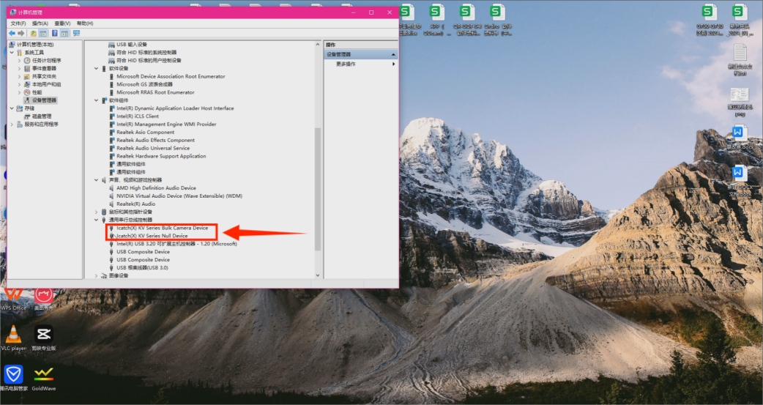

1. 双击打开EP7L固件刷机包,双击FRM.exe打开操作界面

Double-click to open the **EP7L firmware flashing package**, then double-click **FRM.exe** to open the operation interface.

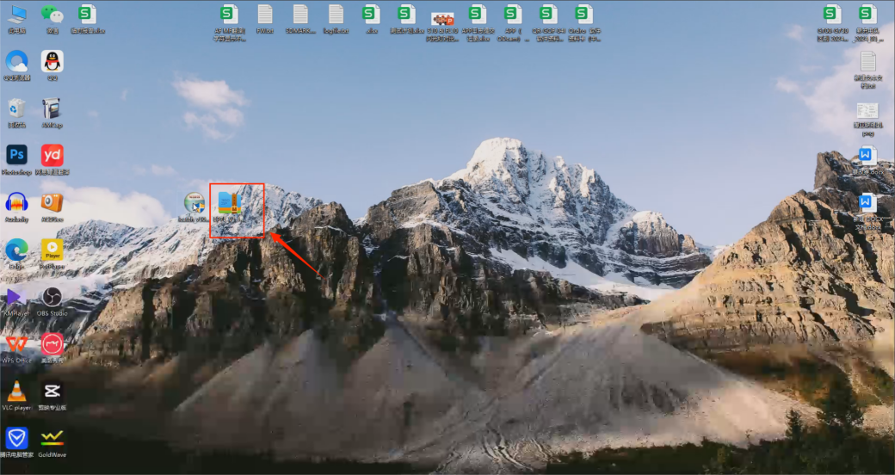

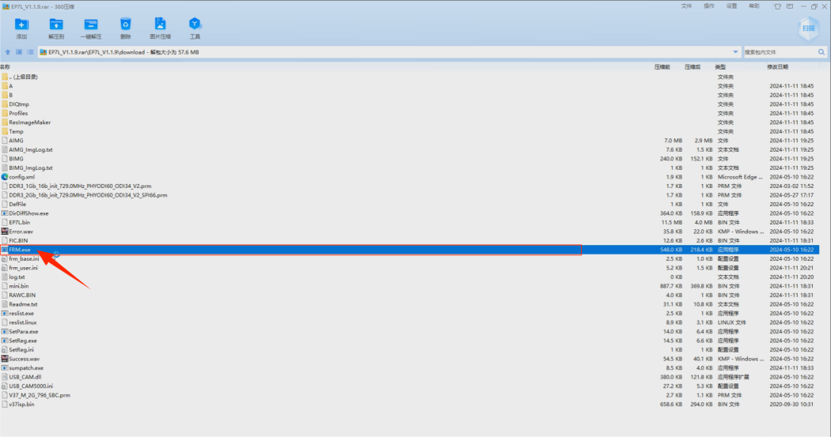

1. 取出EP7PRO和USB数据线，将USB数据线一头接入电脑USB接口，接着先按紧EP7PRO的录像键不放的同时再持续按紧开机键不放，然后再将USB插入EP7PRO的USB接口，这时按着的按键可以放手，点击一下操作界面的ISP(F5)后会自动开始升级

Take out the EP7PRO and USB cable. Connect one end of the USB cable to the computer’s USB port. Then, press and hold the **Video** button on the EP7PRO while also pressing and holding the **Power** button. Afterward, plug the USB cable into the USB port on the EP7PRO. Once the buttons are held down, release them, and click **ISP (F5)** on the operation interface. The upgrade process will automatically begin

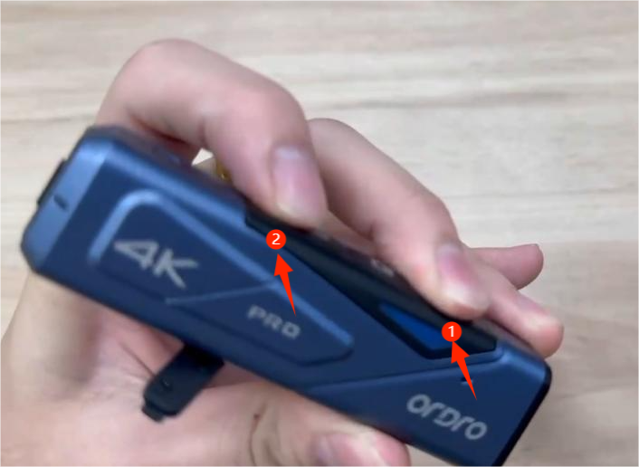

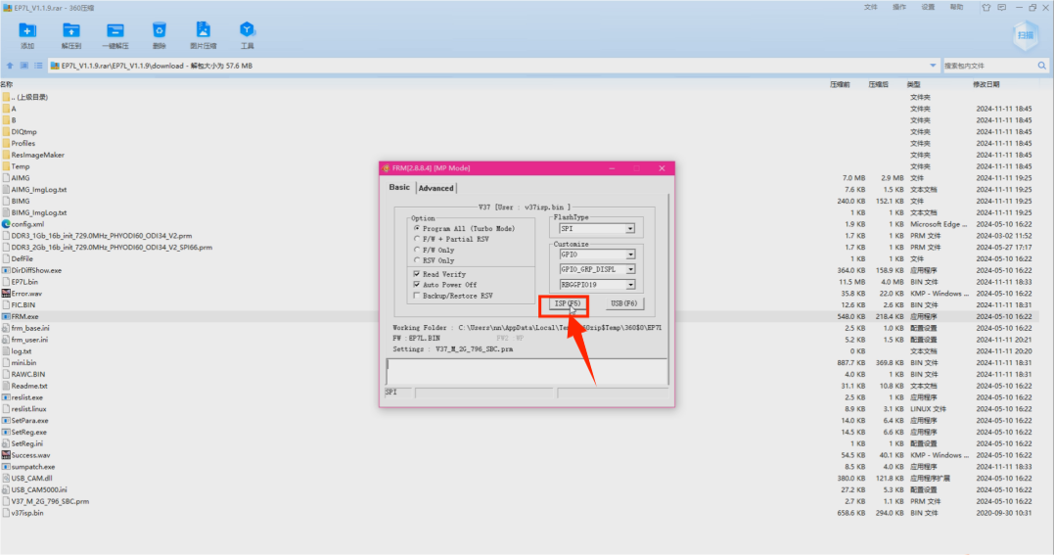

1. 升级完毕操作界面显示ISP Finished。

After the upgrade is complete, the operation interface will display **ISP Finished**.

